**Project Overview**

NextMile is an innovative solution designed to transform fleet operations by leveraging artificial intelligence (AI) to ensure safer, more efficient driving behaviors. This system is tailored for commercial transportation companies, aiming to significantly reduce accidents, enhance driver performance, and cut operational costs.

By offering real-time insights into driver behaviors, NextMile empowers fleet managers to proactively address risks, optimize routes, and improve overall safety compliance.

**Problem Statement**

The Hidden Cost of Unsafe and Inefficient Driving.

In the world of commercial transportation, safety isn't just a priority—it’s a necessity. Yet, fleet operators face ongoing challenges:

1.Driver distraction due to phone usage, drowsiness, or inattention is a leading cause of road accidents.

2.Lack of real-time visibility into driver behavior makes it nearly impossible for fleet managers to take corrective action before an incident occurs.

3.Traditional tracking systems focus on vehicle location, but not on how the vehicle is being driven.

The result? Increased accident rates, higher operational costs, insurance liabilities, and, most importantly, human lives at risk.

**Solution**

NextMile – The One-Stop Solution for Smarter and Safer Operations.

NextMile introduces an AI-powered in-vehicle safety and performance monitoring system designed to revolutionize fleet operations.

**Impact**

By implementing NextMile, fleet operators can expect:

1. Reduced Accidents: By intervening before risky behaviors escalate, NextMile helps lower the number of accidents and incidents.

2. Cost Reduction: With fewer accidents, companies experience lower insurance costs and reduced vehicle maintenance.

3. Improved Driver Accountability: Real-time data promotes safer driving and encourages continuous improvement among drivers.

4. Increased Operational Efficiency: Real-time analytics help optimize routes and driving habits, leading to improved fuel efficiency and reduced operational costs.

5. Enhanced Brand Reputation: Companies that prioritize safety with solutions like NextMile enhance their reputation as responsible, safety-first businesses.

**Technology & Approach**

1. System Installation Inside the Vehicle:

Dual Camera System: Two cameras are installed inside the vehicle: one facing the driver and the other facing the road.

Driver-facing Camera: This camera monitors the driver’s behavior in real-time, capturing details like posture, whether they are distracted, or using a mobile phone.

Road-facing Camera: This camera records the surrounding traffic and road conditions, helping to identify potential hazards.

2. Data Analysis Using Artificial Intelligence:

AI Behavior Monitoring: The system uses AI to analyze the driver’s behavior in real-time:

Distraction Detection: The AI detects behaviors like using a phone, looking away from the road, or other distractions.

Drowsiness Detection: The system analyzes the driver’s posture (e.g., head nodding, eye movements) to identify signs of drowsiness.

Immediate Alerts for Dangerous Behaviors: When risky behavior is detected, an alert is triggered immediately to the driver, and a notification is sent to the control center for further action.

3. Real-time Interaction and Alerts:

Instant Alerts to Drivers: If dangerous behavior is detected, the system immediately notifies the driver via audio or visual alerts, prompting them to correct their actions.

Notifications to Control Center: Simultaneously, real-time notifications are sent to fleet managers or operators, allowing them to monitor the situation and take necessary actions (such as sending reminders or instructions).

4. Data Collection and Long-Term Analysis:

Driver Behavior Analysis: The system continuously collects data about each driver’s behavior, building a profile of their driving patterns, including accident history, driving times, and frequent risky behaviors.

Comprehensive Reports and Analytics: The system provides detailed reports to fleet managers, including strengths and areas for improvement for each driver. This data helps optimize driver training programs and overall fleet management strategies.

5. Cloud Storage and Compliance:

Cloud-Based Storage: All video footage and behavioral data are securely stored in the cloud, allowing easy access for review, compliance, and training purposes.

Compliance Tracking: NextMile ensures companies comply with safety regulations by providing documented evidence of behavioral monitoring, risk assessment, and corrective actions.

6. Ongoing Training and Continuous Improvement:

AI-Driven Training Programs: Based on the insights gathered, the system generates tailored training programs for each driver to improve their driving habits and ensure safety standards are met.

Continuous Monitoring and Evaluation: The system tracks improvements in driver behavior over time and provides ongoing feedback to encourage consistent progress.

**Prototype Feasibility**

The development of a working prototype for NextMile is technically and operationally feasible based on the following points:

1. Technical Feasibility

* The required hardware components (e.g., dual camera system, embedded processing unit such as Jetson Nano or Raspberry Pi, sensors) are commercially available and well-documented.
* AI models for distraction and drowsiness detection (e.g., facial landmark tracking, pose estimation) can be implemented using open-source tools like OpenCV, MediaPipe, or TensorFlow.
* Integration of real-time alerts and cloud communication has been validated in similar vehicle-based monitoring systems.

**Note:** For a detailed list of components, please refer to the [full components reference document](https://drive.google.com/file/d/18UZqg1mLUsU7lDzZHP3qPaiiF1pwE1Yi/view?usp=sharing).

2. Resource Feasibility

* A small-scale prototype can be developed using off-the-shelf components and open-source software libraries.
* Development can be staged, starting with basic camera input and detection logic, followed by cloud integration and dashboard analytics.

3. Cost & Time Feasibility

* A basic prototype is achievable with a modest budget, primarily covering cameras, a processing board, and cloud services.
* A functional prototype (MVP) can be developed within 6–8 weeks by a small team of developers and embedded engineers.

4. Operational Feasibility

* Initial tests can be conducted in controlled environments or test vehicles to validate the system’s behavior.
* Real-world deployment can follow after system calibration and optimization for different lighting, vehicle types, and road conditions.

5. Scalability

* The modular nature of NextMile allows easy scaling to different vehicle types and fleet sizes.
* Cloud-based storage and centralized monitoring ensure the solution remains effective as the fleet grows.

**System Architecture**

The system is designed with a modular architecture, enabling independent development and scaling of components. It comprises the following layers:

• Input Layer: Captures data through camera, microphone, and sensors

• Processing Layer: Processes input using AI models and predefined logic

• Communication Layer: Facilitates data exchange via network protocols.

• Output Layer: Responds through voice, display, or actuator signals.

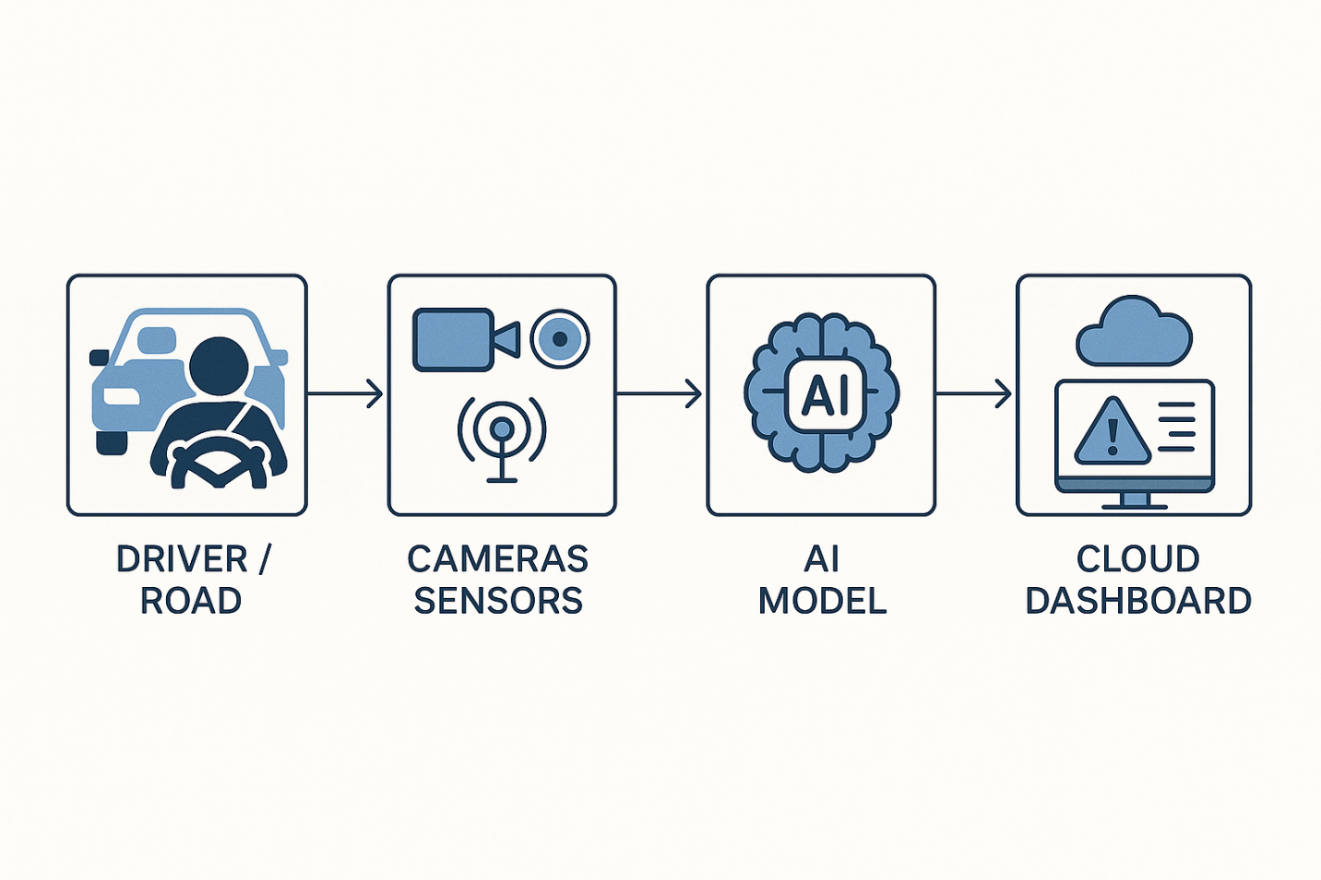

**Future Enhancements**

**Hardware Enhancements**

* Incorporate edge TPU for enhanced AI performance.
* Expand sensor integration (e.g., temperature, gas sensors).

**Software Features**

* Enable machine learning on-device for adaptive behavior.
* Predictive analytics for maintenance alerts.

**System Integrations**

* Develop mobile app interface.
* Integrate with vehicle OBD-II.
* Connect with navigation systems for hazard-aware routing.

**Conclusion**

NextMile is a smart, AI-powered platform designed to revolutionize both fleet operations and smart environments through intelligent automation and real-time interactivity. With its modular and scalable architecture, the system seamlessly integrates computer vision, speech recognition, and sensor-based monitoring to address diverse use cases—from enhancing driver safety in transportation fleets to enabling smart surveillance, home automation, and assistive technologies for individuals with special needs.

*NextMile doesn’t just monitor—it transforms. It’s a step toward a safer, smarter, and more connected future of mobility and automation.*